Module-4) Se - Introduction To Dbms

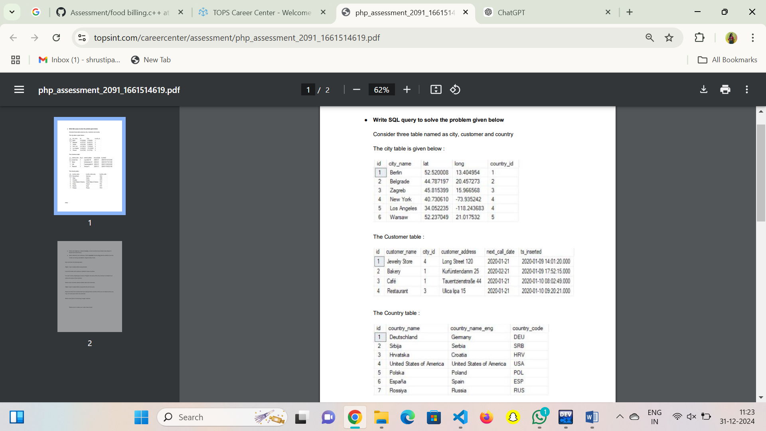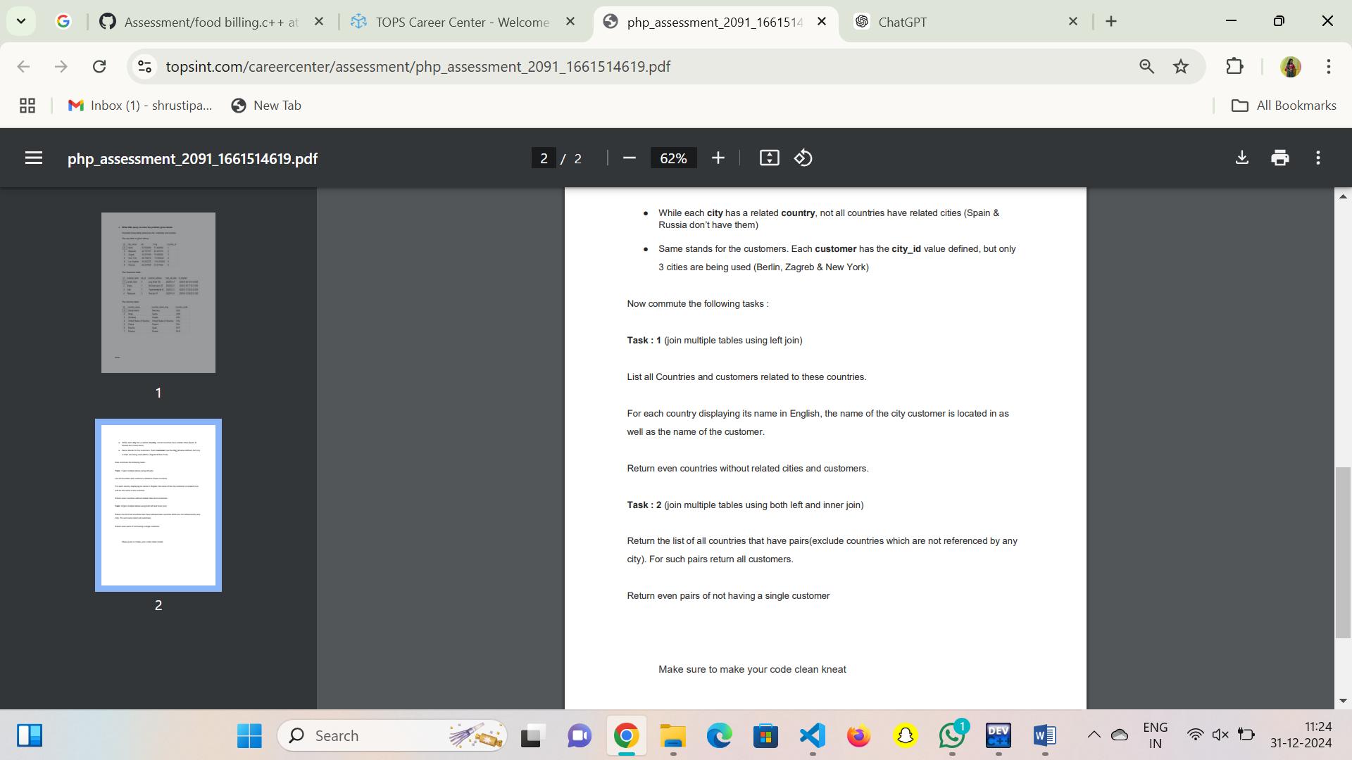

Task -1

SELECT
country.country_name AS Country,
city.city_name AS City,
customer.customer_name AS Customer
FROM
country
LEFT JOIN
city ON country.country_id = city.country_id
LEFT JOIN
customer ON city.city_id = customer.city_id;

Task-2

SELECT
country.country_name AS Country,
city.city_name AS City,
customer.customer_name AS Customer
FROM
country
INNER JOIN
city ON country.country_id = city.country_id
LEFT JOIN
customer ON city.city_id = customer.city_id;

